**Some reminiscences of Australian Geomechanics Society Past-Chairman : Bill Bamford**

1. John Jaeger and his Memorial Award.

In 1959, while working as an Engineering Geologist for the Snowy Mountains Hydro-Electric Authority, investigating the pressure tunnel alignment between Geehi dam site and the M6 underground power station site, I took Professor Jaeger’s team of heat flow measurers from the Australian National University to some of the deep exploratory diamond drill holes on Broken Back Spur, above Khancoban, and assisted them with their measurements.

In 1967, after I had been appointed the inaugural Lecturer in Rock Mechanics at the University of Melbourne, Professor Jaeger invited me to spend some time with him at the Australian National University, to discuss my development of teaching and research in rock mechanics.

I had useful and interesting discussion with John Jaeger, his colleagues Mervyn Paterson and Ted Ringwood, and his postgrad students Kevin Rosengren and Earl Hoskins.

At the 1st Congress of the ISRM in Lisbon in 1966 Lance Endersbee was nominated as the inaugural Vice-President representing the Australasian region. At the conclusion of his term, at the 2nd Congress in Belgrade in 1970, Professor John Jaeger was nominated to be his successor. Ill health prevented him attending that Congress, or any of the successive annual Board and Council meetings. After 1972 Dr Alan Hargreaves was appointed for the remainder of his term to 1974, and then for a full term in his own right until 1979.

Meanwhile I had become Chairman of the AGS national committee in 1975. We became concerned when all notices and committee papers sent to Professor Jaeger at his remote retirement house about 23 km from Port Arthur on the Tasman Peninsula in Tasmania were returned to us uncollected : the house was too remote for mail deliveries and his failing health, and that of his wife, meant that they could not travel in to Port Arthur to collect their mail.

He died in May 1979 and the Committee gave me the task of devising a suitable perpetual memorial for him. I remembered the high pressure triaxial tests on Wombeyan Marble which I had watched while visiting his lab in 1967 and decided to be inspired by that shape and material.

This a photo of one of their test specimens, exhibiting the characteristic failure plane making an angle of 30o to the core axis.

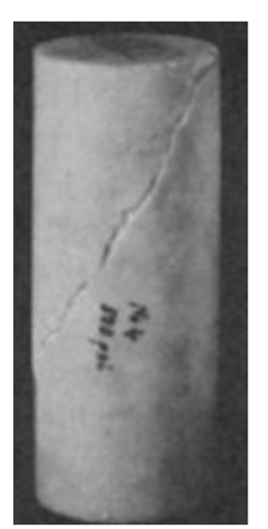

Two distinguished alumni of the University of Melbourne, Roy Hardcastle and Harold Richards, had gone into partnership as Hardcastle & Richards in 1952, and 25 years later decided to celebrate their anniversary to make a gift to the Melbourne School of Engineering. Professor Len Stevens suggested that it should take the form of a sculpture with an engineering theme, to be mounted on the face of the Civil Engineering building, and eminent young sculptor Michael Meszaros was commissioned. (Incidentally his father Andor Meszaros had designed and cast all the medals awarded at the 1956 Melbourne Olympiad.) Len Stevens and Michael Meszaros came up with the following design, which was installed in 1979.

With this as inspiration, Michael and I then came up with the following design, reflecting man overcoming earthen and underground forces.

I found it impractical to perfectly mimic the Wombeyan marble triaxial test specimen, by cutting an oblique plane at 30o to the axis, as the sharp edge tended to break off under slight pressure, so the plane on this and all successive specimens was cut at 45o to the core axis.

The Committee decided that the John Jaeger Memorial Award would be presented at each quadrennial Australia-New Zealand Conference on Geomechanics, with the first presentation to take place in Wellington, New Zealand in May 1980. The inaugural recipient was selected to be Professor Ted Davis.

Manuel Rocha, the President of the ISRM from 1966 to 1970, died in 1981.

By now I was the Vice-President of the ISRM representing the Australasian region, so when I attended the annual Board meeting at which Professor Rocha’s memorial was discussed I tabled a photograph of the John Jaeger Award medal, which the Board passed on to the Portuguese sculptor who was going to be commissioned to design the Rocha Award.

I like to think that some of Michael Meszaros’ vision is reflected in the Rocha medal.

I believe that it is symbolic of a dam founded on inclined rock strata – Manuel Rocha was a distinguished dam designer.

